Dragonfly Class

[Characters in Paverpol - Diana Hume](https://www.facebook.com/Artymiss100/)

This is a short class that takes around 3 hours. Short classes can be scheduled for an evening or an afternoon. No experience needed.

Short classes are generally novelty pieces completed in one evening. I provide all the supplies.

Cost - Tax Included: $55

Click on the link to see a photo album of my friends in Eastend making dragonflies.

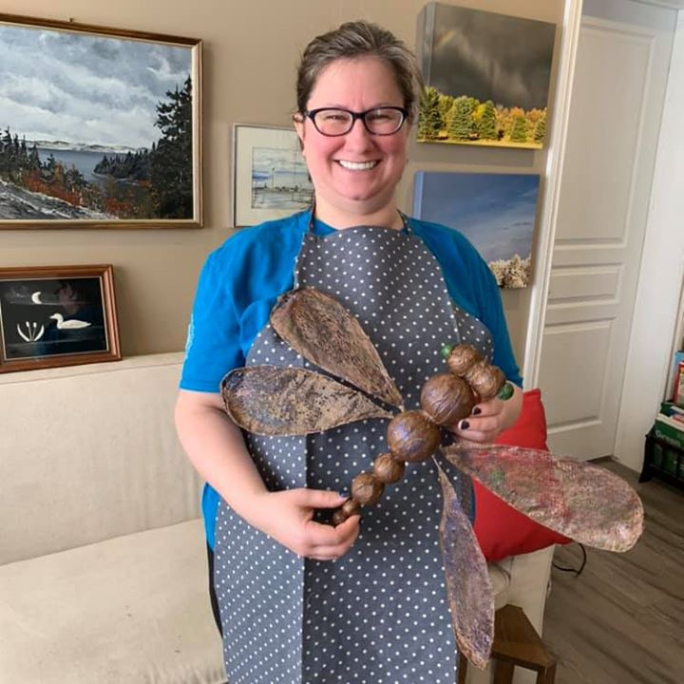

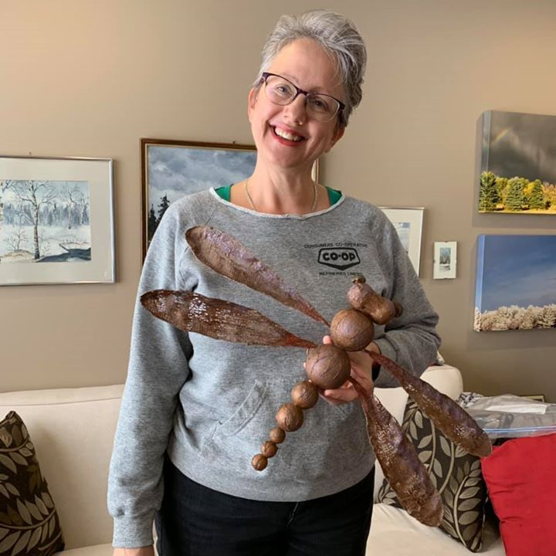

|  |  |  |  |
| --- | --- | --- | --- |
| Image may contain: 1 person, sitting, table, food and indoor | Image may contain: 1 person, smiling, sitting | Image may contain: one or more people and people sitting | Image may contain: bedroom and indoor |
| Image may contain: 2 people, people smiling, people sitting, table, indoor and food | Image may contain: 1 person, sitting and indoor | Image may contain: one or more people and people sitting | Image may contain: 1 person, table and indoor |
| Image may contain: one or more people and indoor | Image may contain: 1 person, sitting, eating, table, food and indoor | Image may contain: food | Image may contain: indoor |

Dragonfly Class Gallery