Introductory Class

 CHARACTERS IN PAVERPOL - DIANA HUME · SUNDAY, MARCH 10, 2019

Participants build up a wire armature with tin foil and masking tape, then wrap it with fabric saturated with Paverpol fabric hardener. This figure is then posed either seated or reclining. Once dried enough to add another layer we will dress and accessorize the figure.

Cost is $120 after taxes. All materials are supplied.

While, given time, I could show you how to make something similar to most things you find in my gallery, the introductory class will start you with the basics.;

Currently I have an introductory Class scheduled in Stoughton Library April 14, 9 – 4:30

Click the link for [information.](https://www.facebook.com/events/293950494606340/)

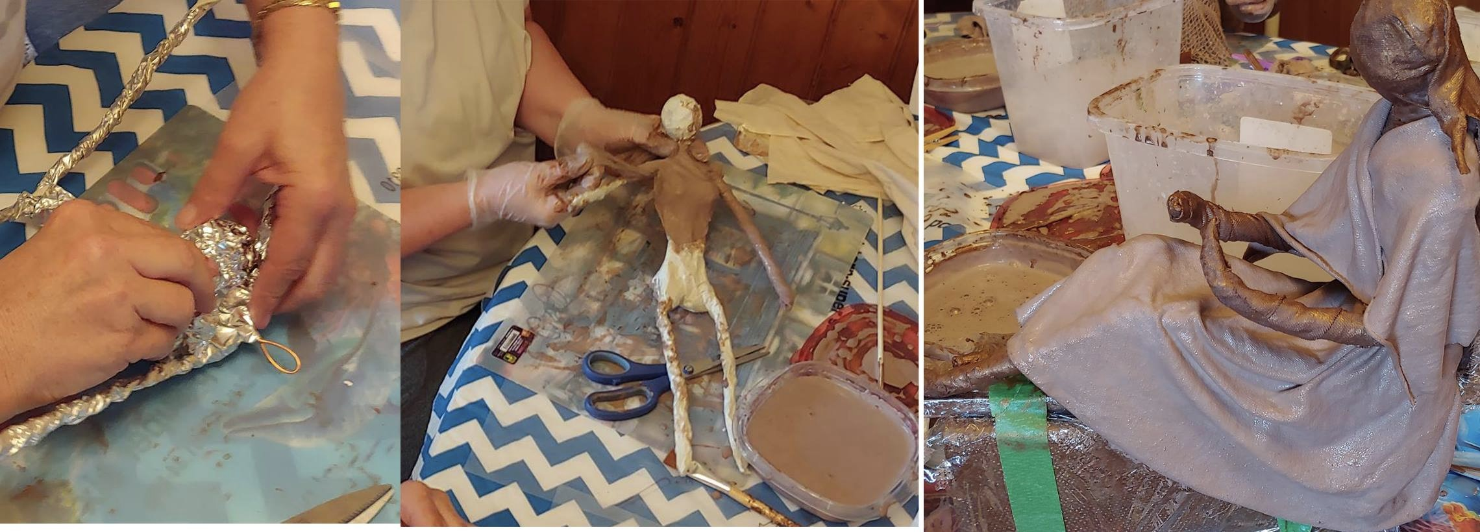We managed to get quite a few pictures at a workshop in Eastend. Click on the link to see the album for an idea what you’ll learn in the introductory class.

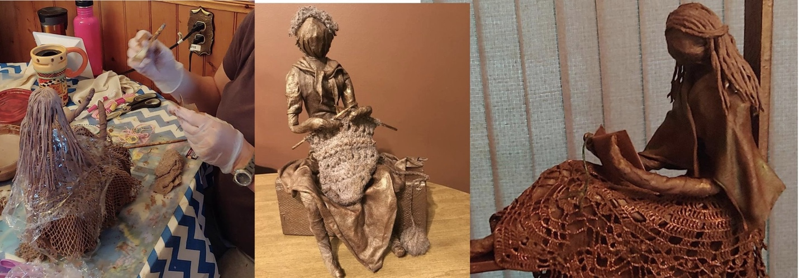Picture 1. Complete the armature with foil, then masking tape Picture 2. Wrap with strips of cloth dipped in Paverpol Pic 3. Dress with Paverpol dipped cloth

Picture 4. Add hair and Accessories Pictures 5 & 6. Finished pieces

|  |  |  |  |
| --- | --- | --- | --- |
|  |  |  |  |
|  |  |  |  |
|  |  |  |  |
|  |  |  |  |
|  |  |  |  |
|  |  |  |  |
|  |  |  |  |
|  |  |  |  |
|  |  |  |  |